1. Fetch date and temperature from temperature_data where zip code is greater than

300000 and less than 399999.

Query : select s_data,temp from temp_data where zip >300000 and zip <399999;

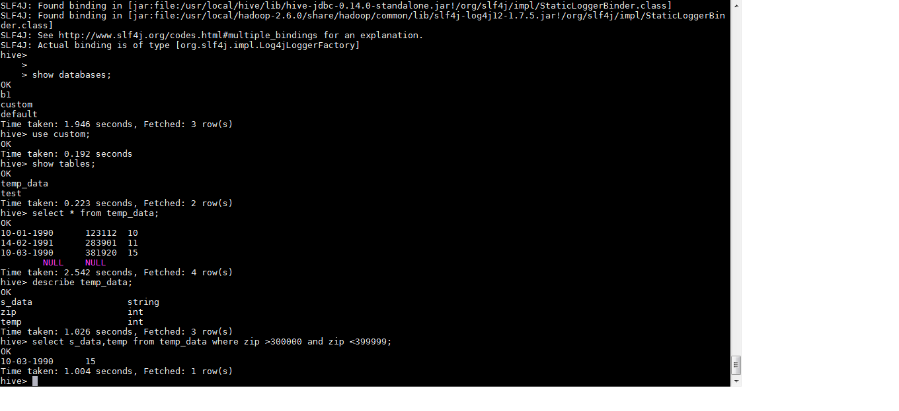

1. Calculate maximum temperature corresponding to every year from temperature_data

table.

Query : select year(from_unixtime(unix_timestamp(s_data,'dd-mm-yyyy'),'yyyy-mm-dd')),max(temp) from temp_data group by year(from_unixtime(unix_timestamp(s_data,'dd-mm-yyyy'),'yyyy-mm-dd'));

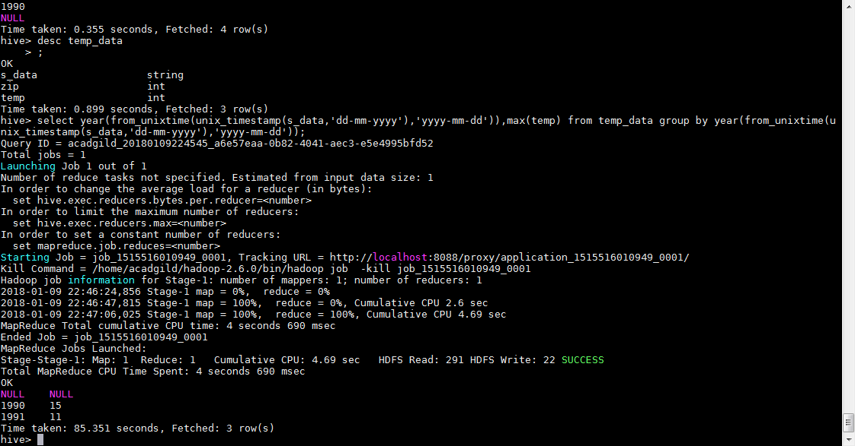

1. Calculate maximum temperature from temperature_data table corresponding to those

years which have at least 2 entries in the table.

: select year(from_unixtime(unix_timestamp(s_data,'dd-mm-yyyy'),'yyyy-mm-dd')),max(temp) from temp_data group by year(from_unixtime(unix_timestamp(s_data,'dd-mm-yyyy'),'yyyy-mm-dd')) having count(year(from_unixtime(unix_timestamp(s_data,'dd-mm-yyyy'),'yyyy-mm-dd'))) >= 2;

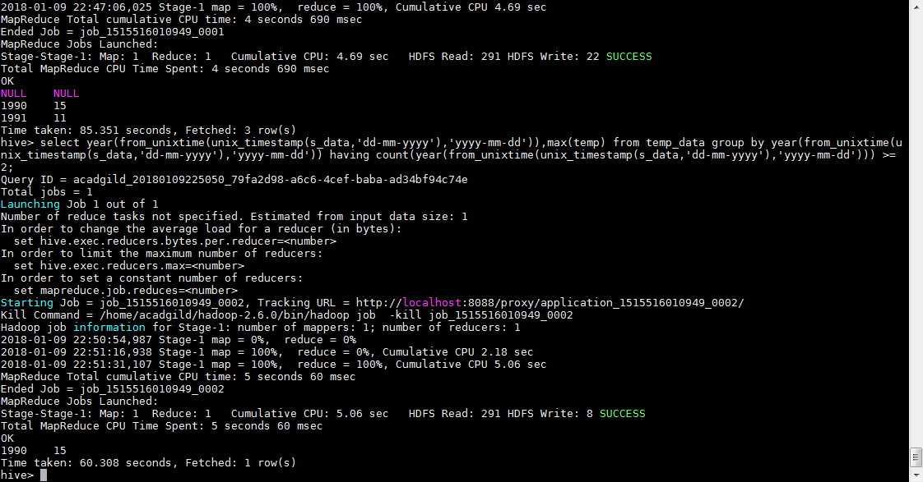

1. Create a view on the top of last query, name it temperature_data_vw.

create view temperature_data_vw select year(from_unixtime(unix_timestamp(s_data,'dd-mm-yyyy'),'yyyy-mm-dd')),max(temp) from temp_data group by year(from_unixtime(unix_timestamp(s_data,'dd-mm-yyyy'),'yyyy-mm-dd')) having count(year(from_unixtime(unix_timestamp(s_data,'dd-mm-yyyy'),'yyyy-mm-dd'))) >= 2;

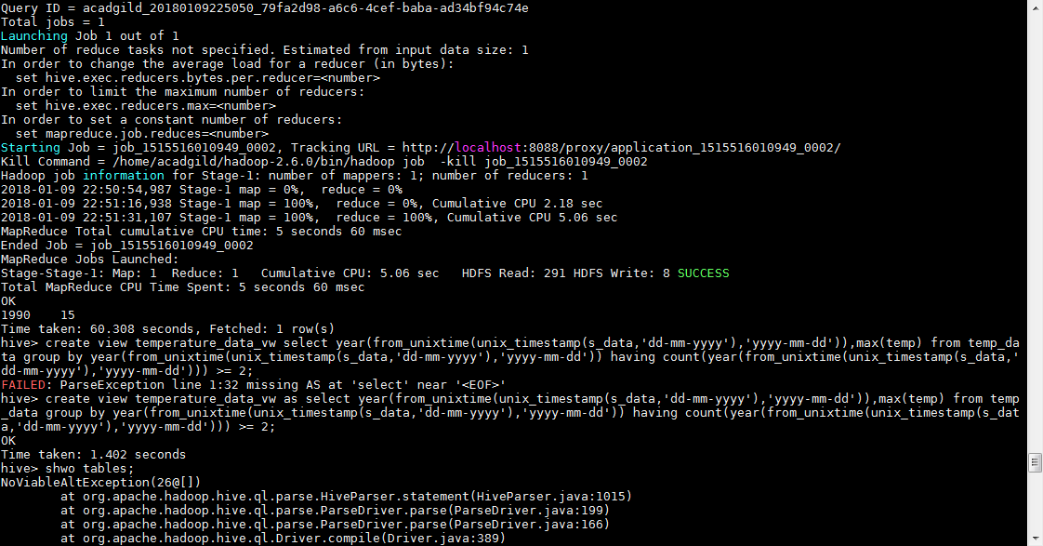

1. Export contents from temperature_data_vw to a file in local file system, such that each

file is '|' delimited.

Query : insert overwrite local directory '/home/acadgild/stage' row format delimited fields terminated by '|' select * from temp_data;

